Name

Mathematics Advanced Year 11
Direct and Inverse Variation

Book 1 |  | Version: 261015  Feedback:  https://MrDingMaths.com
Contents
Syllabus Content 2
Learning Intention 3

Syllabus Content
MAV-11-02 uses functions and relations to model, analyse and solve problems
Direct and inverse variation
- Develop models of the form $y=kx^{n}$, where $k$ is a non-zero constant, from descriptions of situations in which one quantity varies directly with another
- Develop the model $y=\frac{k}{x^{n}}$, where $k$ is a non-zero constant, from descriptions of situations in which one quantity varies inversely with another
- Evaluate $k$ in the equations $y=kx^{n}$ and $y=\frac{k}{x^{n}}$, given one pair of values for the variables, and use the resulting formula to find other values of the variables
- Analyse and solve problems involving direct and inverse variation

Direct and Inverse Variation

- Direct and Inverse Variation
Two quantities are directly proportional if:
- An increase in one quantity causes a proportional increase in the other.
- If you triple one quantity, the second quantity is also tripled.
- A decrease in one quantity causes a proportional decrease in the other.
- If you halve one quantity, the other quantity is also halved.

Two quantities are inversely proportional if:
- An increase in one quantity causes a proportional decrease in the other.
- If you triple one quantity, the second quantity is divided by 3.
- A decrease in one quantity causes a proportional increase in the other.
- If you halve one quantity, the second quantity is doubled.

- Identify examples of direct and inverse proportion
Decide whether these variables are in direct proportion, inverse proportion, or unrelated.
- The numbers of hours worked and amount of money earned for a wage worker. | - The weight of tomatoes purchased and the total amount paid.
- The number of painters and the  time it takes to paint a room. | - The speed of a car and the  time taken to travel a certain distance.
- A person’s height and the  number of pets owned. | - The side length of a square and the perimeter of the square.
- The height of a girl and her  performance in mathematics. | - The flow rate of water from a tap and the time taken to fill a bucket.
- The number of nights at a hotel and the total cost of the stay | - The amount of money borrowed and the amount of simple interest.
- The number of people digging and the time taken to dig a hole. | - The number of flowers in a room and the number of pens.
- Notation and Language of Direct Variation
Direct Variation | Inverse Variation
$$y=kx$$  $$y∝x$$  $y$ is proportional to $x$  $y$ is directly proportional to $x$  $y$ varies directly with $x$ | $$y=\frac{k}{x}$$  $$y∝\frac{1}{x}$$  $y$ is proportional to $\frac{1}{x}$  $y$ is inversely proportional to $x$  $y$ varies inversely with $x$

- Identify direct variation
✖  $$y=3+x$$ | ✔  $$y=3x$$ |  | ✔  $$h=-\frac{2t}{5}$$ |  | ✖  $$h=-\frac{2}{5t}$$
Identify which of the following relationships show direct variation.
- $W=15t$ |  | - $P=3s$ |  | - $P=$ $\frac{3}{s}$
- $y=0.5x$ |  | - $y=\frac{1}{2}x$ |  | - $y=$ $\frac{x}{2}$
- $C=100+5n$ |  | - $y=3x+5$ |  | - $C=3.4+2d$
- $n=4.65g$ |  | - $h=$ $\frac{3x}{2}$ |  | - $l=$ $\frac{3}{2x}$

- Identify inverse variation
✖  $$y=3x$$ | ✔  $$y=\frac{3}{x}$$ |  | ✔  $$p=-\frac{200}{7x}$$ |  | ✖  $$p=-\frac{200}{7x^{2}}$$
Identify which of the following relationships show inverse variation.
- $W=$ $\frac{15}{t}$ |  | - $P=$ $\frac{t}{15}$ |  | - $P=$ $\frac{3}{s}$
- $y=$ $\frac{x}{2}$ |  | - $y=$ $\frac{0.5}{x}$ |  | - $y=$ $\frac{1}{2x}$
- $C=$ $\frac{1}{2}$ $+$ $\frac{1}{x}$ |  | - $y=$ $\frac{3}{x}$ $-5$ |  | - $C=$ $\frac{5924}{x}$
- $n=-$ $\frac{15}{g}$ |  | - $h=$ $\frac{3}{2x}$ |  | - $l=$ $\frac{3}{x}$

- Direct Variation
Two quantities are directly proportional if:
- An increase in one quantity causes a proportional increase in the other.
- If you triple one quantity, the second quantity is also tripled.
- A decrease in one quantity causes a proportional decrease in the other.
- If you halve one quantity, the other quantity is also halved.

The equation of a direct variation relationship is $y=kx$.
A direct variation graph is a straight line passing through the origin.
The constant of variation $k$ is the gradient. It represents the rate of $y$ per $x$.

- Investigation Graph of a direct variation relationship
A train is travelling at a constant speed of 75 km/h.
The distance $d$ travelled in kilometres is directly proportional to time $t$ in hours.
Complete the table of values and sketch the graph.
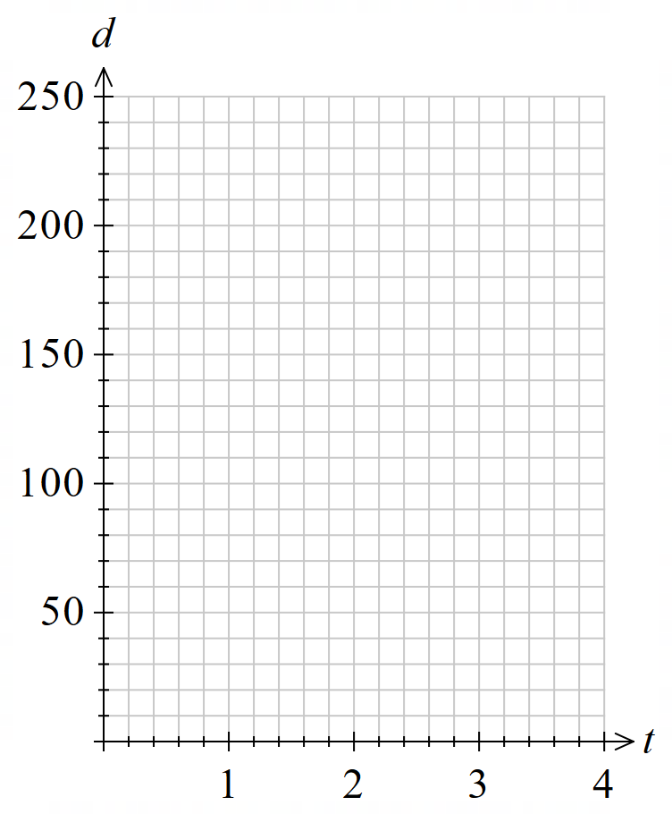
Time (h) $t$ | 0 | 1 | 2 | 3
Distance (km) $d$

What type of graph is this?

This is a …………-line, going through the …………

Find the gradient, which is the constant of variation $k$.

$$m=\frac{rise}{run}=$$

What does $k$ represent in this context?

…………… per ………

Write an equation relating $d$ and $t$:
$y=kx$
…… $=$ ………

- Inverse Variation
Two quantities are inversely proportional if:
- An increase in one quantity causes a proportional decrease in the other.
- If you triple one quantity, the second quantity is divided by 3.
- A decrease in one quantity causes a proportional increase in the other.
- If you halve one quantity, the second quantity is doubled.

The equation of an inverse variation relationship is $y=$ $\frac{k}{x}$.
An inverse variation graph is a smooth curve;
a hyperbolic decreasing curve that never touches the axes.

- Investigation Graph of an inverse variation relationship
A car needs to travel a journey of 60 km.
The time $t$ required in hours is inversely proportional to speed $s$ in km per hour.
Complete the table of values and sketch the graph.
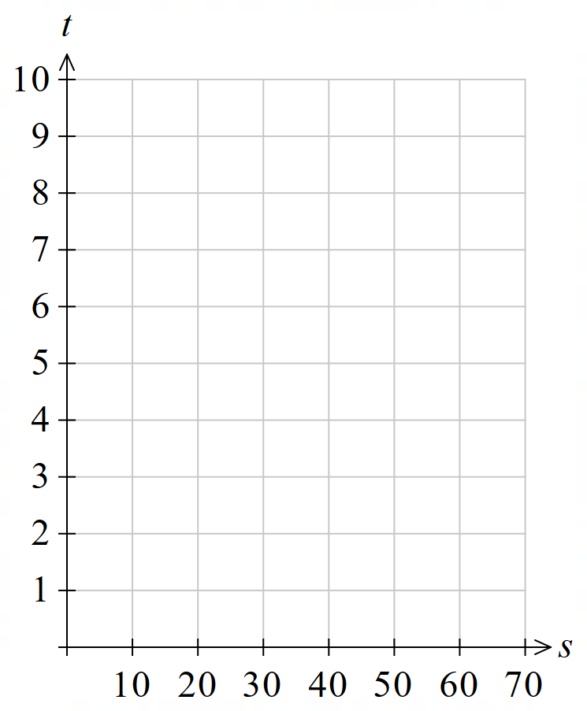
Speed (km/h) $s$ | 0 | 10 | 20 | 30 | 60
Time (h) $t$

What type of graph is this?

This is a h……………… d……………… c……………

Is there a point on the graph for $t=0$?

Is there a point on the graph for $s=0$?

Direct Variation Problems

- Solving Direct Variation Problems
$y∝x$ indicates a direct variation relationship between the two variables.
- Write $y=kx$
- Substitute given information.
- Solve the equation to find the constant of variation $k.$
- Rewrite $y=kx$ with the $k$ you calculated.
- Use your equation to find the required information.

- Example Find the equation of a direct variation relationship
Given that $y∝x$ and $y=4.5$when $x=13.5$:
- Find $y$ when $x=42$
- Find $x$ when $y=7$
1. $y=kx$  2. $4.5=k(13.5)$  3. $\frac{4.5}{13.5}$ $=k$  $$k=\frac{1}{3}$$ | 4. $y=$ $\frac{1}{3}$ $x$  5. Find $y$ when $x=42:$  $$y=\frac{1}{3}\left(42\right)$$  $$=14$$  Find $x$ when $y=7$:  $$7=\frac{1}{3}x$$  $$21=x$$

- Guided Practice
Given that $y∝x$ and $y=42$ when $x=5$, find:
- $y$ when $x=7$
- $x$ when $y=51$

a) 58.8 b) 6.07
Given that $a∝b$ and $a=9.6$ when $b=1.6$, find:
- $a$ when $b=21$
- $b$ when $a=11$

a) 126 b) $\frac{11}{6}$

- Solving Direct Variation Problems
The goal is to find $k$, then write the equation to solve for the unknowns.
- Write $y=kx$
- Substitute given information.
- Solve the equation to find the constant of variation $k.$
- Rewrite $y=kx$ with the $k$ you calculated.
- Use your equation to find the required information.

- Example Model and solve direct variation problems
Garden mulch is sold in bulk, with the cost $C$ proportional the volume $V$ in cubic metres.
The shop says 7.5 m³ costs $270. How much does 12 m³ cost?
1. $C=kV$  2. $270=k×7.5$  3. $\frac{270}{7.5}$ $=k$  $k=36$ | 4. $C=36V$  5. Finding $C$ when $V=12:$  $C=36×12$  $C=\$432$  12 m³ would cost $432.
What does $k=36$ represent in this scenario? (hint: consider the units)

- Guided Practice
The petrol $P$ used by a car at a constant speed is directly proportional to distance travelled $d$.
A car uses 6 L of petrol to travel 50 km.
How much petrol is needed to travel 180 km?
Finding $k:$  $y=kx$  $P=kd$  What does $k$ represent? | Write the equation:  Find $P$ when $d=180$ km:  21.6 L

The amount of paint $P$ needed to paint a wall is directly proportional to the area covered $A$.
A 4-litre can of paint will cover 12 m².
Find the number of litres of paint needed to paint a 63 m² wall.
Finding $k:$  What does $k$ represent? | Write the equation:  Find $P$ when $A=63$ m²:  21 L

- The Gradient is the Rate
A rate compares two quantities.
When two variables are in a straight-line relationship, the gradient is the rate $y$ per $x$.
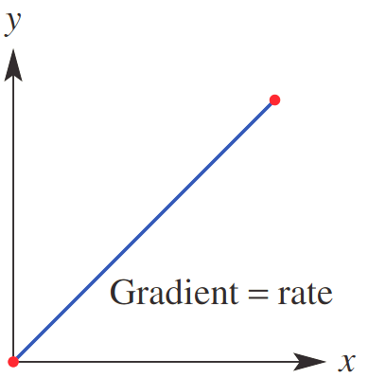
$y=kx$
constant of variation
(gradient)

- Guided Practice
Calculate the gradient, then describe its meaning in each of these direct variation graphs.
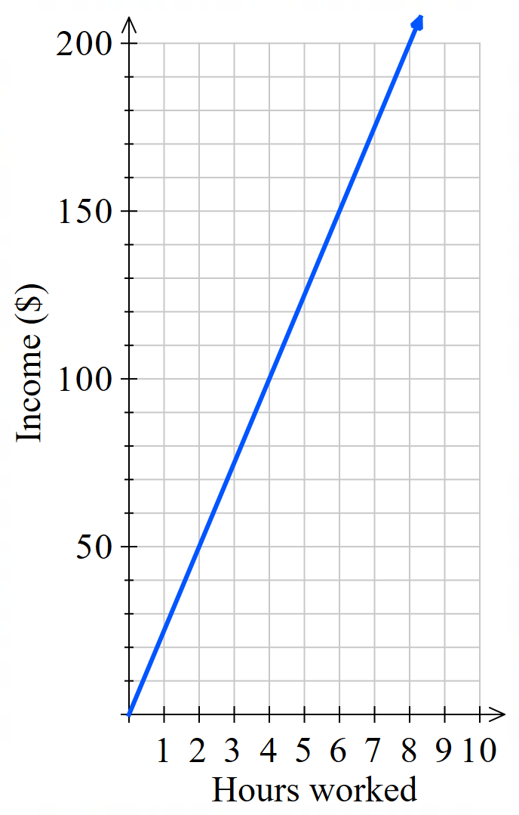  Gradient:  $$m=\frac{rise}{run}=$$  Meaning:  …………… per ………… | 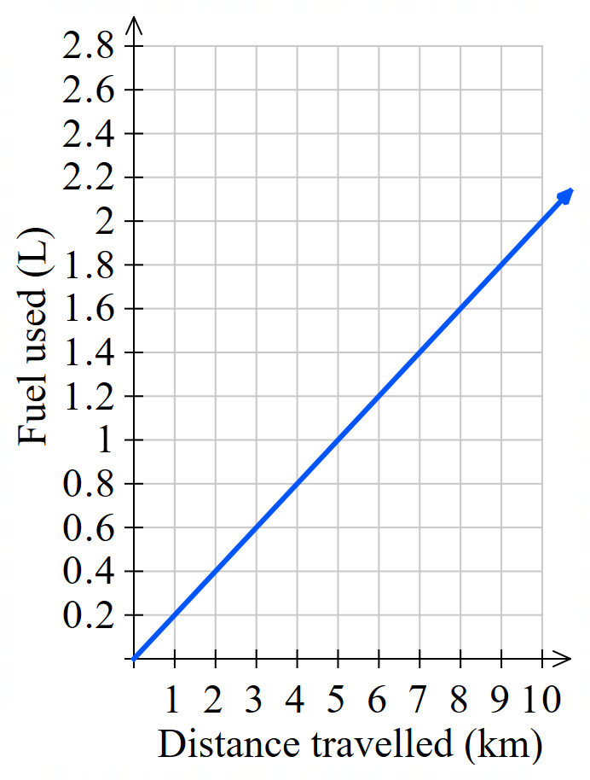  0.2 L per km | 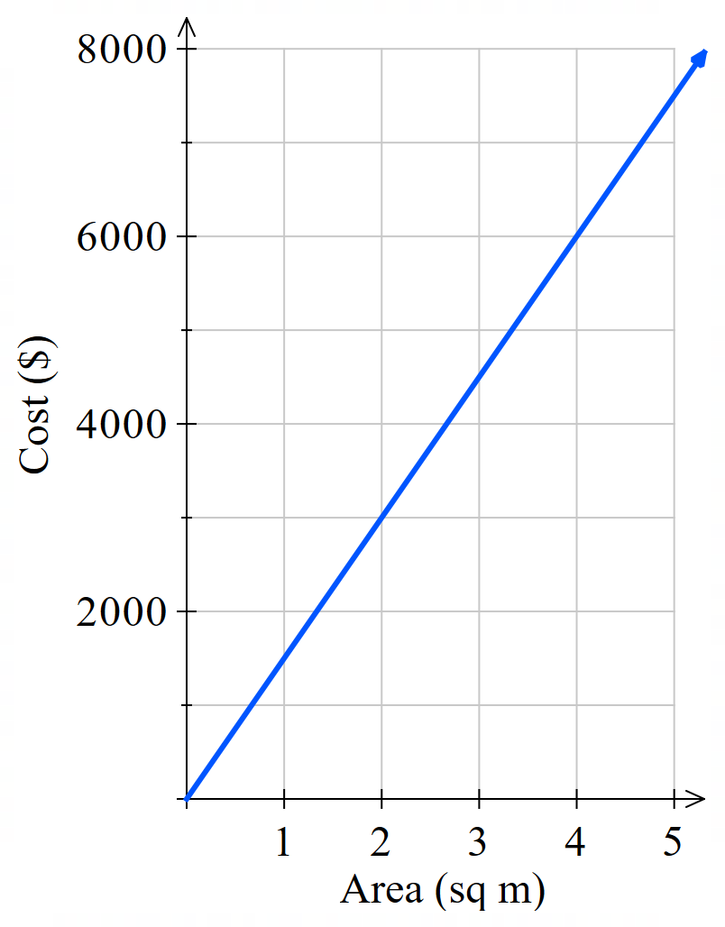  $1500 per sq m

- Example Analyse a direct variation relationship
Mr Ding used to work at McDonalds and was paid $20 an hour.
The number of hours he works and his pay are directly proportional.
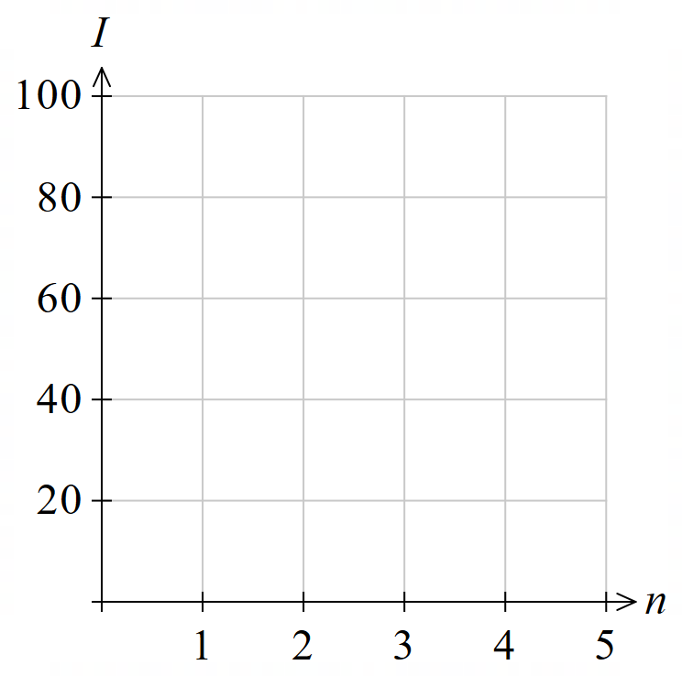
Complete the table of values and draw the graph.
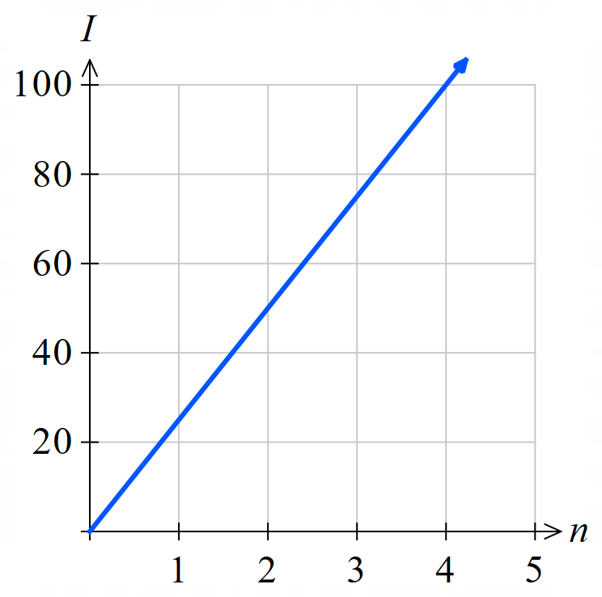
Number of hours $n$ | 0 | 1 | 2 | 3
Income $I$ | 0 | 20 | 40 | 60

Find the gradient, which is the constant of variation $k$.
$$\frac{rise}{run}=20$$

What does $k$ represent in this context?
Pay per hour.

Write an equation relating ($I$) and ($n$).
$y=kx$
$I=20n$

Find his income for 15 hours of work.
$I=20\left(15\right)$
$=300$

Mr Ding wants to buy a PS5 costing $650. Find how long he must work to earn it.
$650=20n$
$$\frac{650}{20}=n$$
$=32.5$ hours

- Guided Practice
- Pens cost $1.50 per pack. Complete the table of values for number of packs $N$ and price $P$
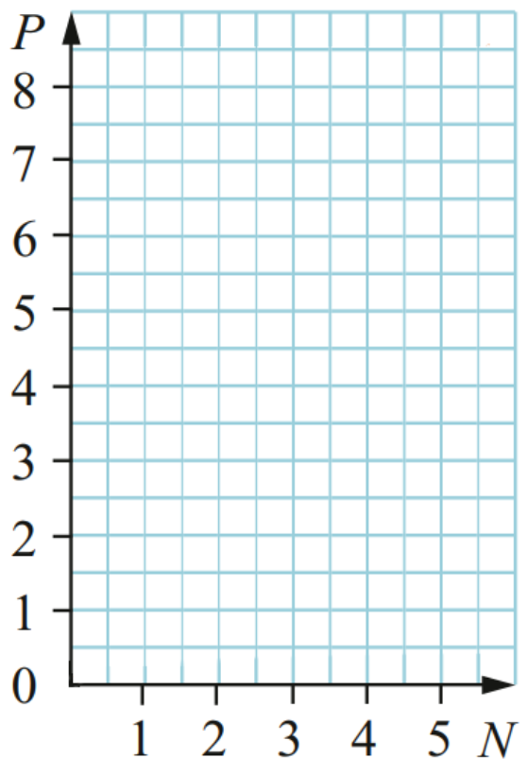
Complete the table and sketch the graph.
$$N$$ | 0 | 1 | 2 | 3
$$P$$
0, 1.5, 3, 4.5
Find the gradient, which is the constant of variation $k$.

1.5
What does $k$ represent in this context?

Cost per pack
Write the equation relating $P$ and $N$.

$P=1.5N$
Find the cost of 9 packs of pencils.

$13.50
How many packs can be bought for $\$27$?

18 packs
- The graph shows distance over time for an express interstate train.
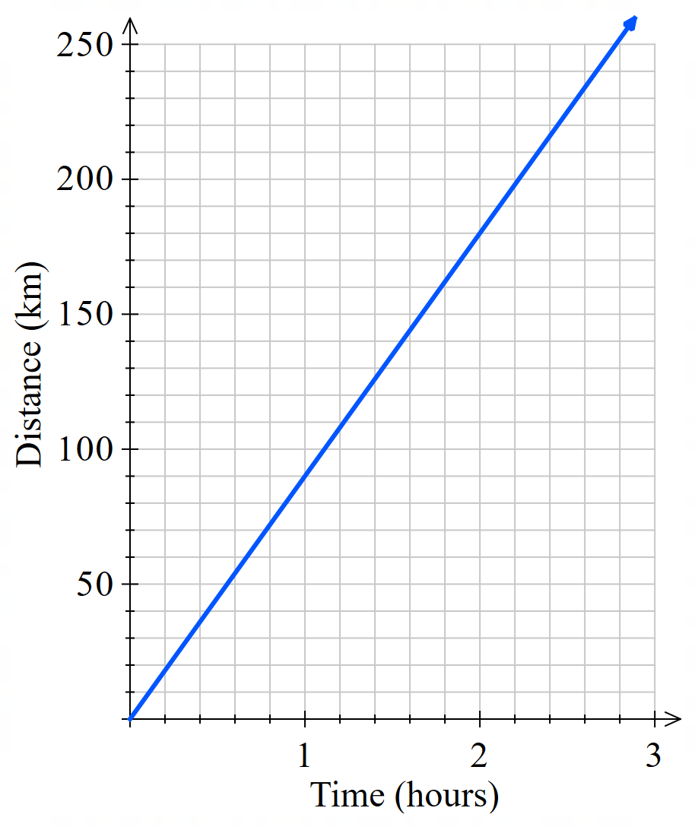
Find the gradient, the constant of variation $k$.

90
What does $k$ represent in this context?

Speed in km/h
Write an equation relating $d$ and $t$.

$d=90t$
How far would the train travel in 12 hours?

1080 km
How long would it take to travel between Sydney and Adelaide, a distance of 1260 km?

14 h

Inverse Variation Problems

- Solving Inverse Variation Problems
- Write $y=$ $\frac{k}{x}$
- Substitute given information.
- Solve the equation to find the constant of variation $k.$
- Rewrite $y=$ $\frac{k}{x}$ with the $k$ you calculated.
- Use your equation to find the required information.

- Example Find the equation of an inverse variation relationship
$y$ $∝$ $\frac{1}{x}$ and $y=4$ when $x=3$.
- Find $y$ when $x=42$
- Find $x$ when $y=7$
1. $y=$ $\frac{k}{x}$  2. $4=$ $\frac{k}{3}$  3.$12=k$  4. $y=$ $\frac{12}{x}$ | 5. Find $y$ when $x=42$:  $$y=\frac{12}{42}=\frac{2}{7}$$  Find $x$ when $y=7$:  $$7=\frac{12}{x}$$  $$x=\frac{12}{7}$$

- Guided Practice
Given $y$ $∝$ $\frac{1}{x}$ and $y=18$ when $x=2$. Find:
  - $y$ when $x=9$
  - $x$ when $y=2$

a) 4 b) 18
Given $y$ $∝$ $\frac{1}{x}$ and $y=3$ when $x=17$. Find:
  - $y$ when $x=102$
  - $x$ when $y=6$

a) 0.5 b) 8.5
- Example Model and solve inverse variation problems
The cost per person of hiring a bus $C$ is inversely proportional to the number of passengers $N.$ When there are 60 passengers, the cost per person is $8.
- Find the cost per person when 45 people go on the bus.
- How many people need to take the bus for the cost to be $6?
1. $C=$ $\frac{k}{N}$  2. $8=$ $\frac{k}{60}$  3. $480=k$  4. $C=$ $\frac{480}{N}$ | 5. Find $C$ when $N=45$:  $$C=\frac{480}{45}$$  $$=\$10.67$$  Find $N$ when $C=6$:  $$6=\frac{480}{N}$$  $$6N=480$$  $$N=\frac{480}{6}=80 people$$
What does $k$ represent in this scenario? (Hint: what does $60×\$8$ find?)

- Guided Practice
The number of painters $N$ is inversely proportional to the amount of time to paint a fence $t$.
3 painters can paint a fence in 12 hours. Find:
- Find how many painters are needed to paint the fence in 9 hours.
- How long it would take 2 people to paint the fence.

a) 4 painters b) 18 hrs

- Inverse Variation with Graphs
Two quantities are inversely proportional if:
- An increase in one quantity causes a proportional decrease in the other.
- A decrease in one quantity causes a proportional increase in the other.
The graph of inverse variation is a hyperbola, also called a reciprocal relationship.
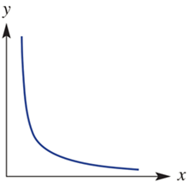
constant of
proportionality
$y=\frac{k}{x}$

- Example Interpret a reciprocal model
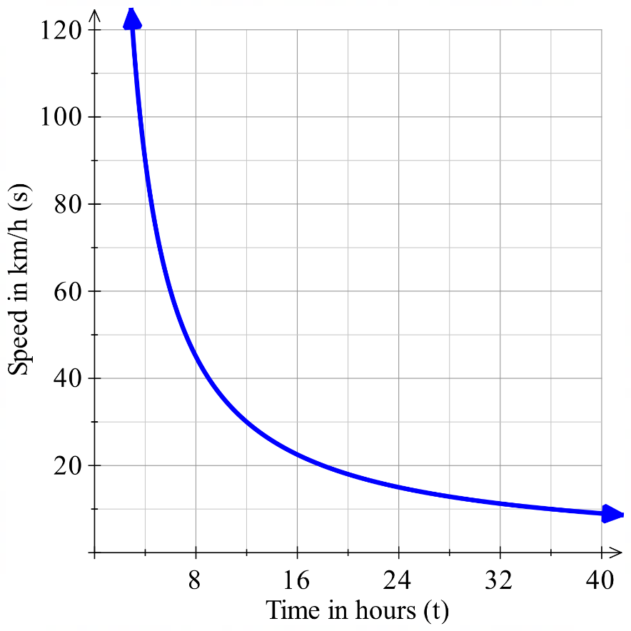
The equation $s=$ $\frac{400}{t}$ can be used to model the average speed needed to travel 400 km in a particular time, where $s$ is speed in km/h and $t$ is time in hours.
What is the average speed required to complete a
400 km trip in 5 hours?
Using graph: $≈$ 80 km/h
Using equation: $s=$ $\frac{400}{5}$ $=80$km/h
How long would it take to complete the trip at 95 km/h?
Using graph: $≈$ 4 hours
Using equation: $95=$ $\frac{400}{t}$
$t=$ $\frac{400}{95}$ $≈4.21$ hours
$=$ 4 hours 13 minutes.
Why is it impossible for $t=0$? Explain by referring to the context of the model.
We would have $s=\frac{}{}$, which is u…d…………… In the context of the model, we cannot travel ………… km in ………… hours, this would require …………… speed.
Why is it impossible for $s=0$? Explain by referring to the context of the model.
We would have $0=\frac{400}{t}$, which is impossible. In the context of the model, it is not possible to travel …………… km at ………… speed, it would require ……………… time.
Why did we not consider the other half of the hyperbola?
………………… cannot be negative.

- Guided Practice
Paul rents a guesthouse from the landlord for $720 per week.
To save money, he has other people stay and divides the expense equally.
The equation that models this situation is $C=$ $\frac{720}{n}$, where $C$ is cost in dollars per person and $n$ is the number of people staying per week.
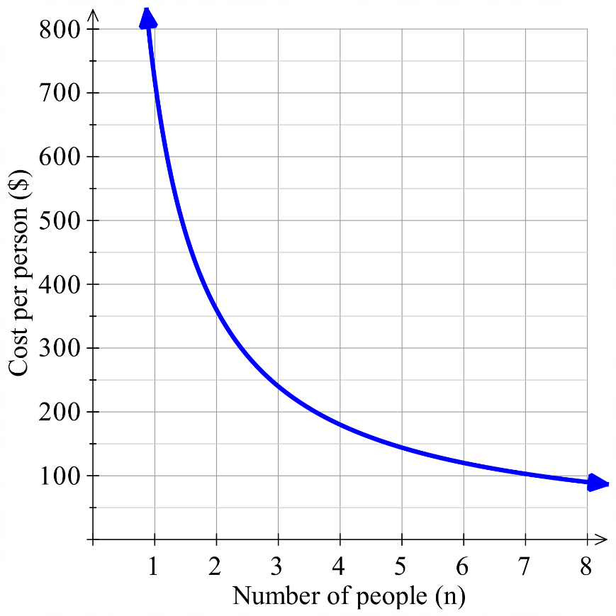
  - What is the cost per person when 3 people
are staying?

$240
  - How many people are needed so cost per person
is $144?

5 people
  - What are the limitations of this model? (hint: can $n$ be a fraction?)

$n≥1$ and must be a whole number.
The equation $s=$ $\frac{360}{t}$ can be used to model the average speed necessary to travel 360 km in a particular time, where $t$ is the time in hours and $s$ is the speed in kilometres per hour.
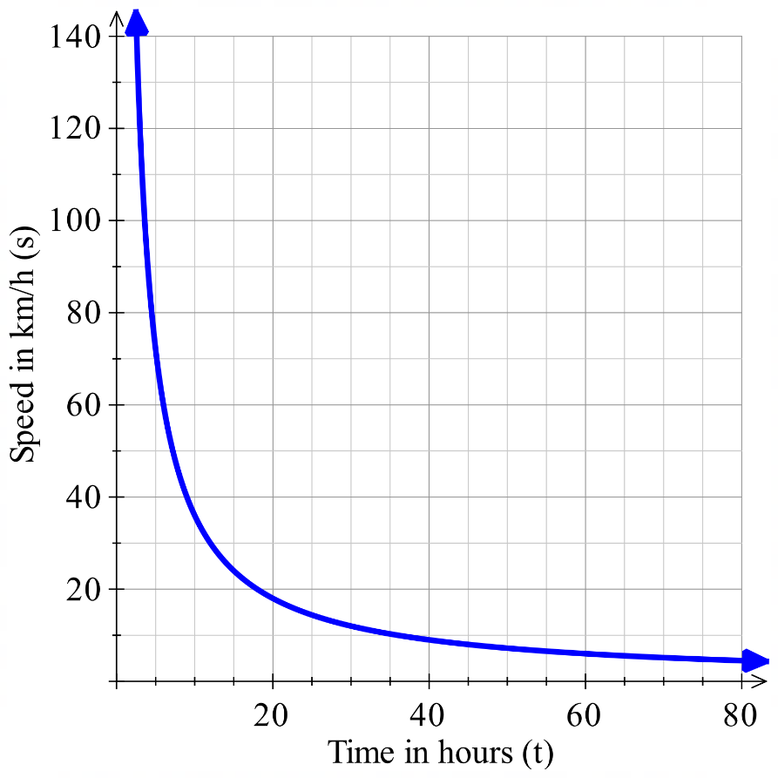
  - What does the 360 represent?

Total distance
  - What average speed is required to complete the 360 km trip in 12 hours?

30 km/h
  - How long would it take to complete the trip at 75 km/h?

4.8 h

Direct and Inverse Power Variation

- Direct and Inverse Variation with Power Functions
Power variation happens when one variable is proportional to a power of another variable.
Direct Power Variation  $$y∝x^{n}$$  E.g.  Sphere volume $V∝r^{3}$ | Inverse Power Variation  $$y∝\frac{1}{x^{n}} or y∝x^{-n}$$  E.g.  Inverse square law $I∝$ $\frac{1}{d^{2}}$
- Write $y=kx^{n}$ or $y=$ $\frac{k}{x^{n}}$.
- Substitute given information.
- Solve the equation to find the constant of variation $k.$
- Rewrite the equation with the $k$ you calculated.
- Use your equation to find the required information.

- Example Solve problems involving power variation
The mass, $m$, of a solid ball is directly proportional to the cube of its radius $r$.
At $r=2$, $m=24.$Find the radius when $m=192$.
1. $m=kr^{3}$  2. $24=k{\left(2\right)}^{3}$  3. $24=8k$  $k=3$ | 4. $m=3r^{3}$  5. $192=3r^{3}$  $64=r^{3}$  $r=4$

The inverse square law states that the intensity of light is inversely proportional to the square of the distance from the source. $I∝$ $\frac{1}{d^{2}}$.
What happens to the intensity of light if you triple the distance from the source?
$$I=\frac{k}{d^{2}}$$
At triple the distance
$$I=\frac{k}{{\left(3d\right)}^{2}}$$
$$I=\frac{k}{9d^{2}}=\frac{1}{9}×\frac{k}{d^{2}}$$
The intensity of light is one ninth of what it was previously.

- Guided Practice
The stopping distance $d,$ in metres, varies directly with the square of speed $v$, in km/h.
At $v=40$, $d=20$. Find the stopping distance at $v=60$.

45 m
A pendulum’s period $T$, in seconds, varies directly with $\sqrt{L}$, where $L$ is the length of the pendulum in metres. When a pendulum is 0.81 m, its period is 1.8 seconds.
Find the period when the pendulum is 1.44 m.

2.4 s
A pendulum’s period $T$, in seconds, varies directly with $\sqrt{L}$, where $L$ is the length of the pendulum in metres. What happens to the period if you double the length?

The period is $\sqrt{2}$ or 1.414… times the original
$I∝$ $\frac{1}{d^{2}}$. If $d$ decreases by 20%, what is the percentage change in $I$?

56.25%

